ACH and Credit Card Recurring Payment Authorization Form
Schedule your payment to be automatically deducted from your checking or savings account. Just complete and sign this form to get started!

Recurring Payments Will Make Your Life Easier: It’s convenient, saving you time and postage and your payment is always on time.

Here’s How Recurring Payments Work: You authorize regularly scheduled charges to your checking or savings account. You will be charged the amount indicated below at each billing period. A receipt for each payment will be emailed to you and the charge will appear on your bank statement as “Star of Hope ACH Debit - Sage.”

Please complete the information below for all payments:

I ____________________________ authorize Star of Hope to charge my bank account
(Full name)
indicated below on the 28th of each month for my known gift to Star of Hope.

Billing Address ____________________________ Phone# ________________________
City, State, Zip ____________________________ Email ________________________

Account Type: Checking Savings
Name on Acct _______________________________
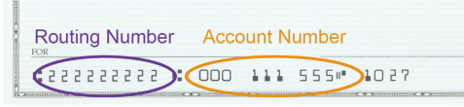
Bank Name _______________________________
Account Number _______________________________
Bank Routing # _______________________________
Bank City/State _______________________________

Credit Card Visa MC AX Discover
Name on card _______________________________

Card Number _______________________________
Exp date M/Y _______________________________
CVC _______________________________

SIGNATURE DATE

I understand that this authorization will remain in effect until I cancel it in writing. If the above noted periodic payment dates fall on a weekend or holiday, I understand that the payment may be executed on the next business day. I understand that because this is an electronic transaction, these funds may be withdrawn from my account as soon as the above noted periodic transaction dates. I agree not to dispute this recurring billing with my bank so long as the transactions correspond to the terms indicated in this authorization form.

Thank you for your support.
Star of Hope

